Количество записей в каждой из таблиц

SELECT COUNT(*) FROM db_linkBetweenURL

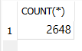  
SELECT COUNT(*) FROM db_linkWord



SELECT COUNT(*) FROM db_urlList



SELECT COUNT(*) FROM db_wordList



SELECT COUNT(*) FROM db_wordLocation



20 наиболее часто встречающихся доменов

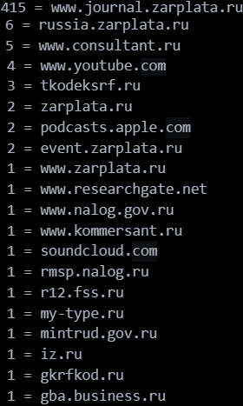

20 наиболее часто встречающихся слов

SELECT T2.word, COUNT(T1.fk_word_id) AS count

FROM db_wordLocation AS T1

INNER JOIN db_wordList AS T2 ON T1.fk_word_id = T2.id

GROUP BY T1.fk_word_id

ORDER BY count DESC

LIMIT 20;

